

Hospital report
  - power bI
Hospitla general Information



details of report
This Power BI report enables users to analyze hospital performance across key quality domains (Mortality, Safety, Readmissions) and to simulate improvement scenarios using interactive What-If parameters. The report supports data-driven decision-making by allowing users to explore how changes in performance thresholds and improvement assumptions affect hospital ratings and outcomes.

Data Refresh
- The report is connected to hospital performance data stored in a structured dataset.
- To refresh the data:
  - Open the Power BI report.
  - Click Home → Refresh.
- After refresh, all visuals, KPIs, and scenario simulations automatically update.
- Blank hospital ratings are handled using a median-imputed rating, ensuring stability after refresh.

Matrix Visual
Displays Facility Name × Hospital Type.
Shows:
- Overall Hospital Rating
- Count of “Worse” measures for Mortality, Safety, and Readmissions.
Supports right-click drill-through to view detailed hospital-level analysis.

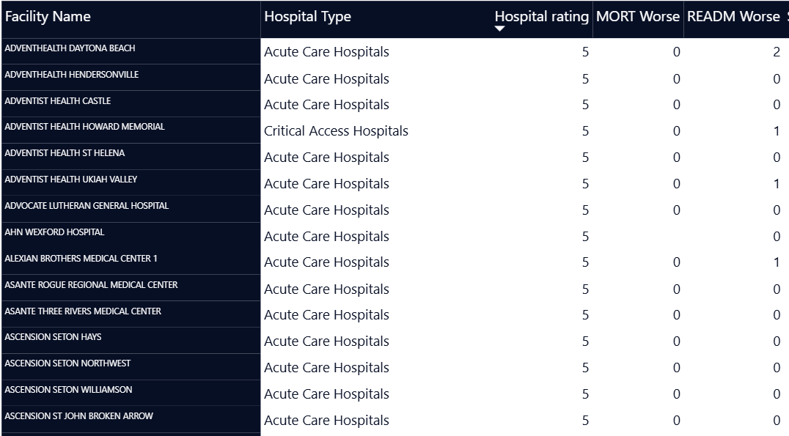
Figure 1

Drill-Through
- Opens a detailed view for a selected hospital.
- Displays:
  - Hospital rating
  - Domain-level Worse / Better / No Different counts
  - Adjusted values based on scenario parameters.

Key KPI’s
High-Performing Hospitals (Card)
- Displays the number of hospitals meeting or exceeding the selected Rating Threshold.
- Updates dynamically as the threshold slider changes.
Projected Safety Improvement (Line Chart)
- Shows the projected percentage of “Better” Safety measures as the improvement parameter increases.
Readmission Risk Analysis (Scatter Plot)
- Plots Overall Rating vs. Worse Readmission Measures.
- Colour by Hospital Ownership to identify patterns across ownership types

Slicers and What If Parameters

Rating Threshold Slider
- Allows users to define what rating qualifies as “High-Performing” (e.g., ≥ 3, ≥ 4, ≥ 5).
- Updates KPIs and visuals in real time.
Improvement Shift Slider
- Simulates improvement by shifting a selected percentage of “Worse” measures into “No Different / Better”.
- Used to model hypothetical quality improvement scenarios (0%–100%).

ERD Diagram
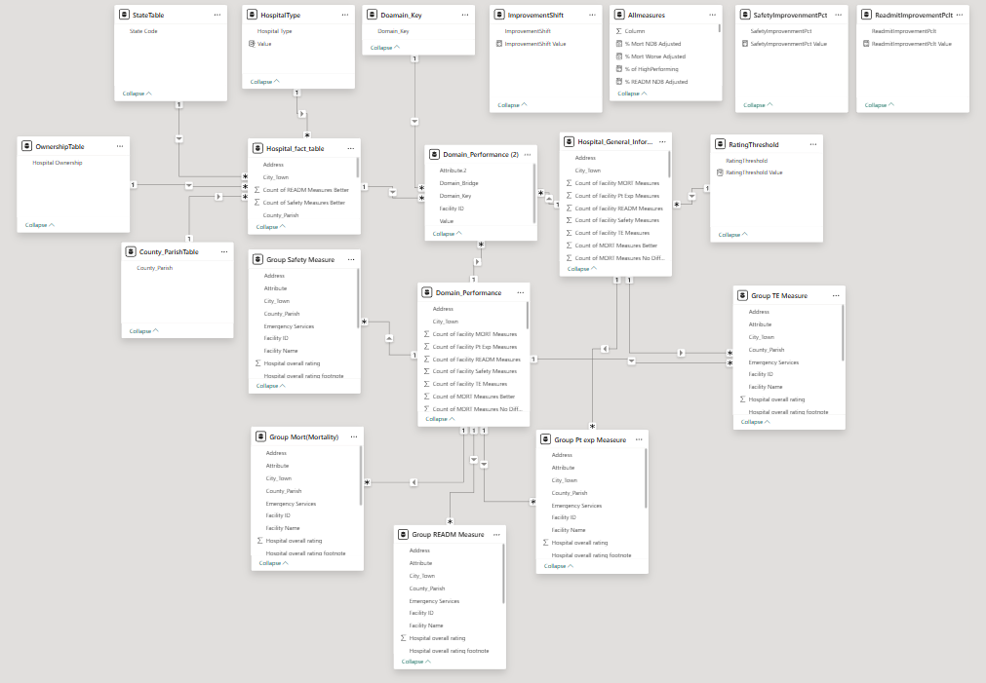

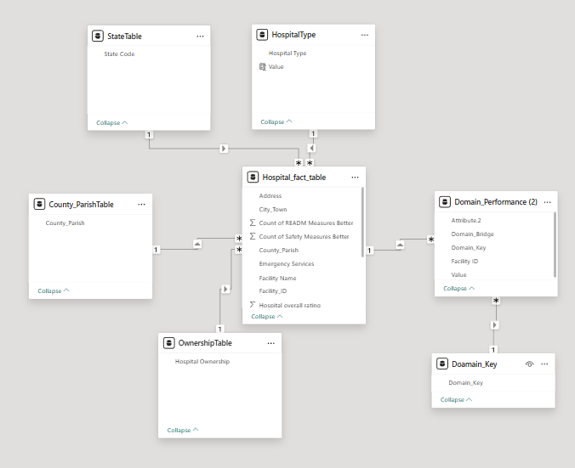

Data Model Overview
Primary Table
Hospital Fact Table
- Facility Name (Primary Identifier)
- Hospital Type
- Hospital Ownership
- Overall Hospital Rating
- Mortality Performance (Worse / No Different / Better counts)
- Safety Performance (Worse / No Different / Better counts)
- Readmission Performance (Worse / No Different / Better counts)
Parameter Tables (Disconnected)
- Rating Threshold
Rating Threshold Value
- Improvement Shift
Improvement Shift Value
Relationships
- Hospital Fact Table → Parameter tables: No physical relationship
- Parameters interact through DAX measures only
- This design avoids filter ambiguity and improves scenario modelling.

Dax Measures
- TotalHospitals = DISTINCTCOUNT(Hospital_fact_table[Facility_ID])
- Total Mortality/READM/Safety =
SUM('Hospital_General_Information'[Count of MORT/READM/Safety Measures Worse]) +
SUM('Hospital_General_Information'[Count of MORT/READM/Safety Measures No Different]) +
SUM('Hospital_General_Information'[Count of MORT/READM/Safety Measures Better])
- Mort/READM/Safety countof better/no different/worse = COUNTROWS(CALCULATETABLE(Domain_Performance,Domain_Performance[Count of MORT/READM/Safety Measures Better/no different/worse]))
- Mort/READM/Safety count of facility = COUNTROWS (CALCULATETABLE(Domain_Performance, Domain_Performance[Count of Facility Mort/READM/Safety Measures]))
- Mort/Read /Safety% of Better/Worse = DIVIDE([Safetycountof Better/worse],[Safety count of facility])*100
- AvgOverallRating = AVERAGE(Hospital_fact_table[Hospital overall rating])
- High Performing Hospitals =
CALCULATE(
DISTINCTCOUNT('Hospital_fact_table'[Facility Name]),
FILTER(
'Hospital_fact_table',
'Hospital_fact_table'[Hospital overall rating] >= 'RatingThreshold'[RatingThreshold Value]))
- % of High Performing = DIVIDE([High Performing Hospitals],[Total Hospitals])*100
- HospitalsAboveThreshold = CALCULATE( [TotalHospitals], Hospital_fact_table[Hospital overall rating] >= 3)
- Median Hospital Rating =
MEDIAN('Hospital_fact_table'[Hospital overall rating])
- PctBirthingFriendly = DIVIDE( CALCULATE(COUNTROWS(Hospital_fact_table), Hospital_fact_table[Meets criteria for birthing friendly designation] = "Yes")*100, [TotalHospitals])
- PctD MORT/READ/SAFETY Better/No Different/Worse =
DIVIDE(
SUM(Domain_Performance[Count of MORT/READ/SAFETY Measures Better]),
SUM(Domain_Performance[Count of MORT/READ/SAFETY Measures Better])
+ SUM(Domain_Performance[Count of MORT/READ/SAFETY Measures No Different])
+ SUM(Domain_Performance[Count of MORT/READ/SAFETY Measures Worse]),0)
- PctEmergency = DIVIDE(CALCULATE(COUNTROWS(Hospital_fact_table), Hospital_fact_table[Emergency Services] = "Yes")*100, [TotalHospitals])

3. Power Query (Data Transformation Steps)
Key Power Query Steps Applied
- Imported CSV source
- Promoted headers
- Renamed columns for consistency
- Converted rating fields to numeric data type
- Replaced non-numeric values with nulls
- Removed duplicate hospital records
- Retained original rating column (no overwrite)
- Created calculated column in DAX for median imputation
Why Median Imputation Was Used
- Robust against skewed data
- Prevents artificial inflation
- Ensures consistent behaviour after refresh

4. What-If Parameter Configuration
Rating Threshold
- Type: Whole number
- Range: 1 to 5
- Purpose: Classify High vs Low Performing Hospitals
Improvement Shift
- Type: Decimal567
- Range: 0 to 1 (0%–100%)
- Purpose: Simulate improvement by reallocating “Worse” measures

5. Instructions to Add a New Performance Domain
(Example: Adding “Patient Experience”)
Step 1 — Data Preparation
Ensure the dataset includes:
Mort/READM/Safety
- Worse
- No Different
- Better

6. Data Refresh & Validation
- Refresh via Home → Refresh
- Validate:
  - No blank ratings after imputation
  - What-If parameters respond correctly
  - Drill-through remains functional

Adjusted Mort, READM & Safety Worse =
SUM('Hospital_Fact_Table'[Mort, READM & Safety Worse]) *
(1 - [ImprovementShift Value])

Adjusted Mort, READM & Safety NDB =
SUM('Hospital_Fact_Table'[Mort/READM/Safety No Different]) +
SUM('Hospital_Fact_Table'[Mort/READM/Safety Better]) +
( SUM('Hospital_Fact_Table'[Mort, READM/Safety/Worse]) * [ImprovementShift Value] )

% Mort/Read/Safety NDB Adjusted =
DIVIDE([Adjusted Mort Read/Safety NDB], [Total Mortality/Read/Safety])

% Mort/Rea d/Safety Worse Adjusted =
DIVIDE([Adjusted Mort Read/Safety Worse], [Total Mortality])

VISUALS

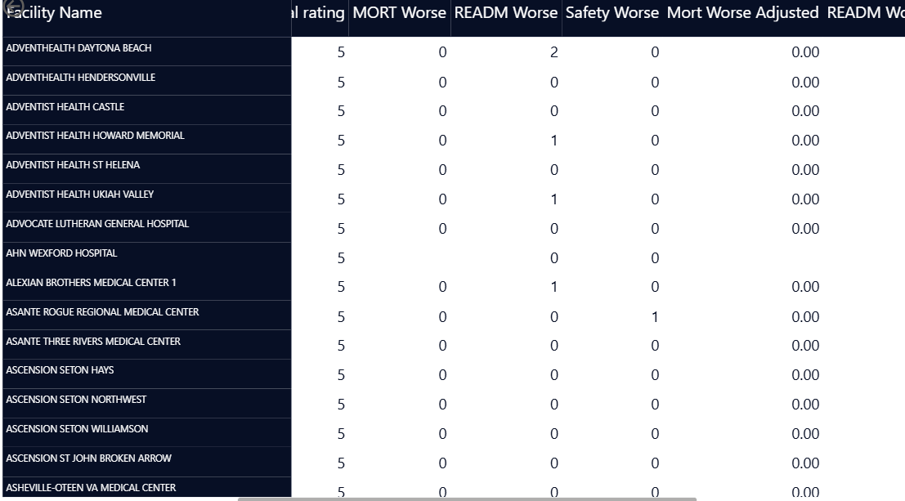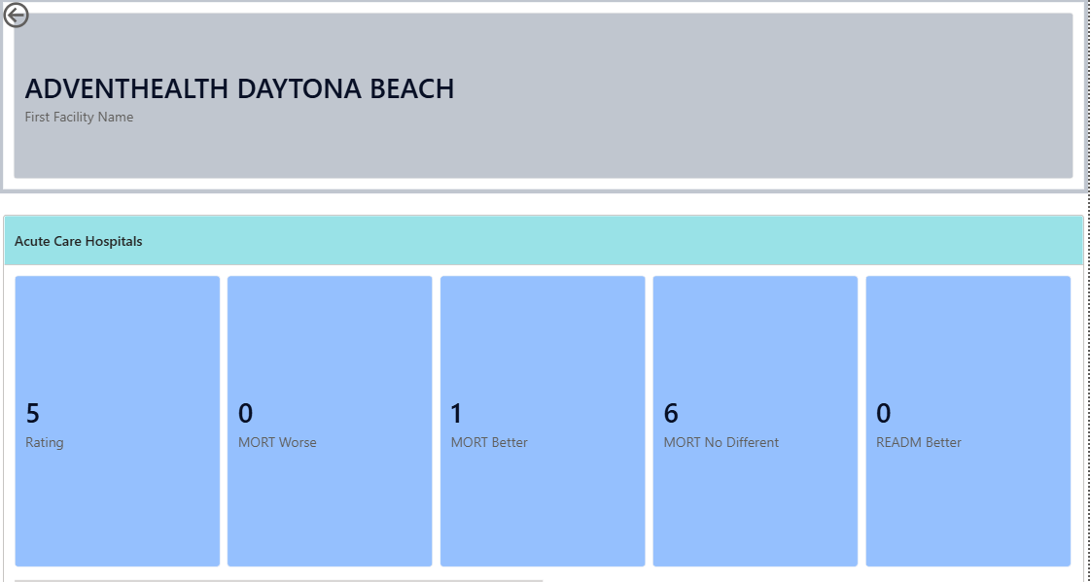

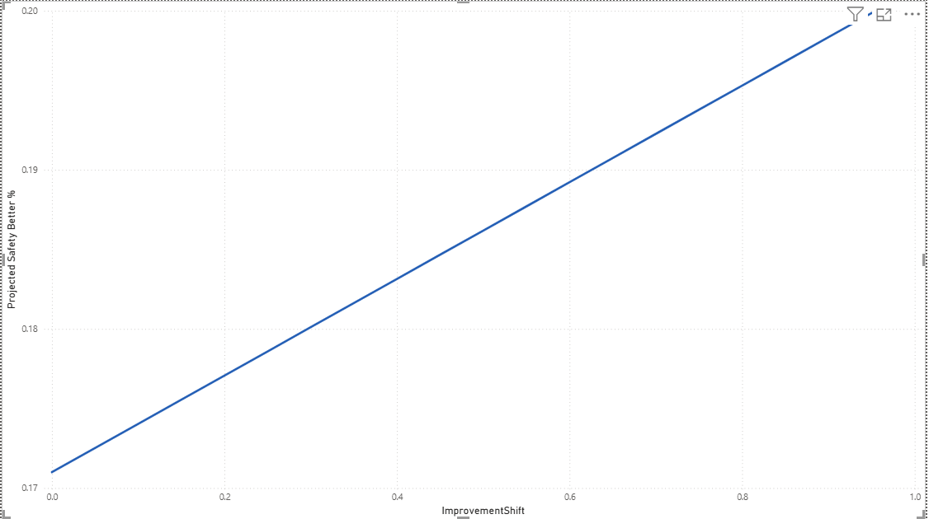
Executive Summary

This analysis examines hospital general information data to evaluate hospital availability, quality ratings, emergency preparedness, ownership structure, and performance across key healthcare domains. Using Power BI, we developed an interactive dashboard with KPIs, geographic views, domain-level performance analysis, and what-if scenario modeling to support data-driven healthcare decision-making.

The dataset provides insights into:

Distribution of hospitals by type and ownership

Overall quality ratings

Emergency and birthing service availability

Performance outcomes across mortality, safety, readmission, patient experience, and treatment effectiveness

Potential impact of performance improvements through scenario analysis

🔍 Key Insights
1️⃣ Hospital Distribution & Capacity

General Acute Care hospitals form the majority of facilities, indicating a strong focus on broad medical services.

Specialized hospitals (Critical Access, Children’s, VA) represent a smaller but essential segment, often serving rural or targeted populations.

Hospital ownership is dominated by voluntary non-profit and government facilities, highlighting the public-service nature of healthcare delivery.

2️⃣ Overall Quality Ratings

The average overall hospital rating falls in the mid-range, suggesting moderate national performance.

Only a limited percentage of hospitals exceed higher rating thresholds, as seen in the What-If scenario analysis.

Increasing the rating threshold significantly reduces the number of qualifying hospitals, indicating opportunities for quality improvement.

3️⃣ Emergency & Birthing Services

A high proportion of hospitals offer emergency services, reflecting strong emergency care coverage.

However, birthing-friendly hospitals form a smaller share, suggesting:

Limited maternity-focused infrastructure

Potential gaps in maternal and neonatal care in certain regions

4️⃣ Geographic Patterns

Hospital density and quality vary significantly by state.

Some states have:

High hospital counts but average ratings

Fewer hospitals but higher performance scores

This indicates that quantity does not always correlate with quality.

5️⃣ Domain Performance Analysis

Across the five CMS performance domains:

🏥 Mortality (MORT)

A larger proportion of hospitals fall under “No Different”, with fewer classified as “Better”.

Indicates scope for improving patient outcomes and clinical practices.

🛡 Safety

Safety performance shows better results than mortality, but “Worse” outcomes still exist in certain regions or hospital types.

🔁 Readmission (READM)

Readmission performance varies widely.

Improvement scenarios show that even small percentage improvements can significantly reduce poor outcomes.

😊 Patient Experience (Pt Exp)

This domain shows stronger performance, with more hospitals rated as “Better”.

Highlights growing emphasis on patient-centered care.

💊 Treatment Effectiveness (TE)

Generally stable performance with room for optimization, especially in lower-performing facilities.

6️⃣ What-If Scenario Insights

Increasing Safety and Readmission improvement percentages results in noticeable gains in projected performance.

The scenario modeling demonstrates that:

Targeted quality initiatives can substantially improve hospital outcomes.

Policy interventions and hospital investments can be simulated before real-world implementation.

📈 Business & Healthcare Implications

Healthcare policymakers can identify underperforming domains and regions.

Hospital administrators can benchmark performance against peers.

Patients benefit from improved transparency and informed hospital selection.

Resource allocation can be optimized toward safety, maternal care, and readmission reduction.

✅ Conclusion

The hospital general information analysis reveals that while healthcare infrastructure is widely available, quality and performance are uneven across regions and domains. Emergency care coverage is strong, but maternal care and high-quality outcomes require further attention.

Domain-level analysis highlights patient experience as a relative strength, while mortality and readmission present key opportunities for improvement. What-if scenario modeling confirms that incremental performance improvements can lead to meaningful system-wide benefits.

Overall, this Power BI dashboard provides a robust decision-support tool that enables stakeholders to monitor performance, identify gaps, and test improvement strategies—ultimately supporting better healthcare outcomes and policy decisions.

